Contents

1. FOREWORD 3
2. Installation 4
2.1. Package contents 4
2.2. Ports of the Telejet Keyboard Simulator-HUB 4
2.3. Ports of the Telejet Keyboard Simulator 6
3. SETUP 7
3.1. Example 7
3.2. How to build up 8
3.3. Concatenation of TKS-HUBS 9
3.4. Cable-check 10
4. SOFTWARE 11
4.1 Basics 11
4.2. Usage of Software 11

1 Foreword

The amount of data to be provided these days for internet and database use is only achievable with an adequate capacity of serving PCs. Therefore, many computers must be purchased and maintained. The drop-out of a single PC can cause malfunctions of the entire system. Thus, a service technician must be available to react immediately. But an actual hardware-defect as a cause for a malfunction is an exception. Rebooting of the failed PC recovers its operation in most cases.

Up to now, a service technician had to come even for a simple rebooting process. This caused unnecessary expenses and tied expensive resources for a trivial operation.

TELEJET Web Resetter now impowers you to remote control and to reset up to 3000 Server-PCs via keyboard simulation!

All appearing names of products are used with the intention to explain circumstances and are in most cases trade-marks of their owners.

2 Installation

3 Package contents

- 1 Telejet Keyboard Simulator Hub
(abbreviated as TKS-Hub in the following)
- 4 blue up-/downlink- cables of different lengths
- RS-232-cable for connection to server
- Power supply (12V, 800mA, AC/AC)

2.2. Ports of the TKS-HUB

On the front, there are the following plugs:

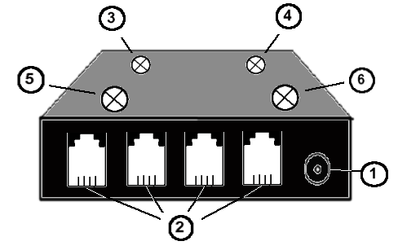

- Power supply
- RJ11-plugs for Telejet Keyboard -Simulators or additional TKS-HUBs.
- LED indicates when data is being received
- LED for cable-check
- LED indicates when data is being sent
- Power-LED

The ports on the back of the device are shown beneath:
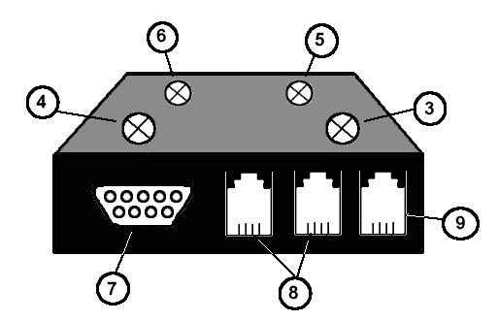

- LED for cable-check
- LED indicates data is being received
- Power-LED
- LED indicates data is being received
- RS232 plug to the Web-Resetter-Server
- RJ11 plugs for cable check
- RJ11 plug for uplink-port

2.3. Connectors of Telejet Keyboard Simulator

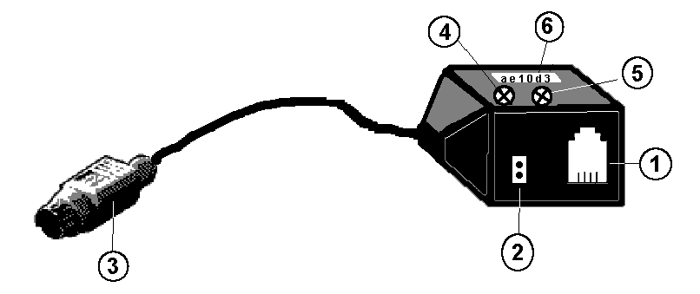

- RJ11-plug to the Hub / linking of TKS
- Plug for hardware-reset-cable
- PS/2 keyboard-plug
- LED (green) TKS is sending/receiving Data
(active mode)
- LED (yellow) TKS is in idle mode
- TKS-ID (six-digit hexadecimal-code)

4 Setup

3.1 Example

A typical Setup of a TELEJET Keyboard Simulator Hub and 300 TELEJET Keyboard Simulators is diagrammed beneath.
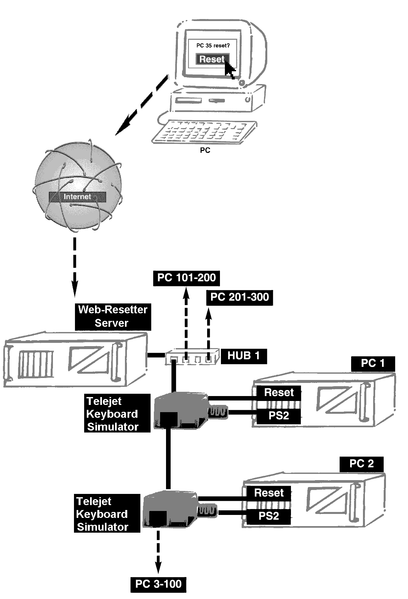

Important:
Power down your equipment prior to connecting any PS/2 devices such as the Telejet Keyboard Simulator!

3.2. How to build up

Connect the TELEJET Keyboard Simulator HUB to the Webresetter-Server´s serial interface using the provided serial cable. Now connect the first TELEJET Keyboard Simulator (TKS) to the PS/2 keyboard interface of the first PC in line. Optionally, you can now also connect the mainboard´s reset-cable to TKS. Consult the mainboard manual to find the location in PC. Afterwards, you can connect the TKS to the TKS-HUB with the provided RJ11 cables.
Now link further TKS to the proceeding TKS.

Important:
The total number of 100 TELEJET Keyboard Simulators connected to one port of a TELEJET Keyboard Simulator HUB must not be exceeded. Moreover the total length of connection cables must not exceed 100m to ensure a safe operation! Up to 300 TELEJET Keyboard Simulators are connectable to one HUB.

3.3. Concatenation of TKS-HUBs

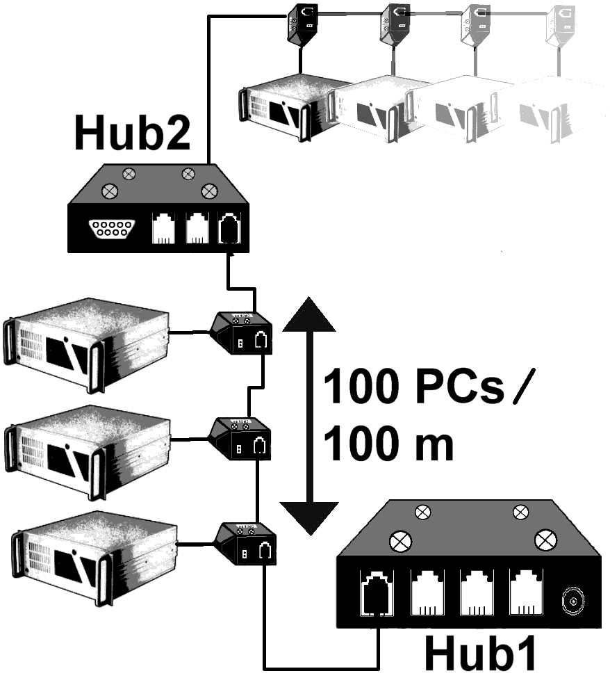

Important:
Within the limits of 100m cable-length, 100 PCs per port and 300 TKS per TKS-HUB you can arbitrarily link TELEJET Keyboard Simulator HUBs. Up to 10 TKS-HUBs are cascadable and 3000 PCs are controllable this way.

On the prior page, the integration of additional TKS-HUBs is shown in case of exceeding the limit of 300 PCs or 100m cable-length.The uplink port of Hub 2 is to be connected to a regular TKS port of Hub 1. You can compare it´s operation to a simple repeater. LED(4) is lit to display uplink-traffic.

3.4. Cable-check

Connect a cable to the two ports as shown beneath.
If this cable is intact and capable, LED (3) is lit. You can both check a single cable and a complete network of TKS.
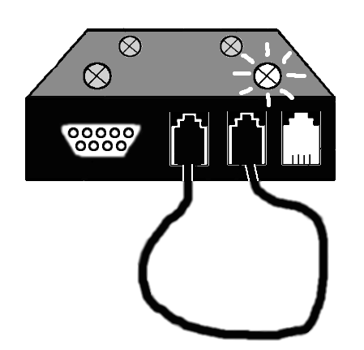
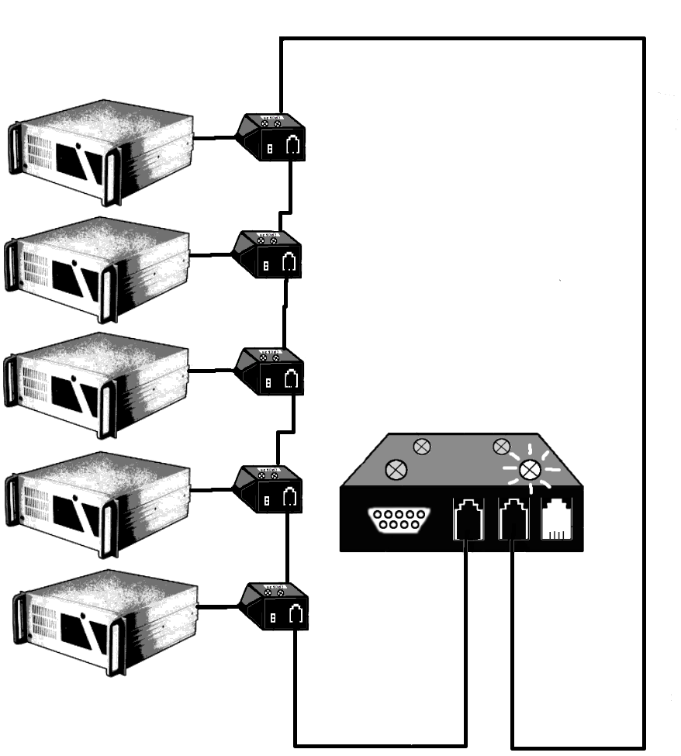

4. Software

4.1. Basics

The software is downloadable at the following URL:
http://www.webresetter.de
It features a Perlscript for Linux Apache Webserver, easily portable to Windows, including a sample website and test software for Windows. The Software is a rudimentary program including all essential functions to direct TKS. Customers may develop a tailored software based on the provided source code.
Please note that your Web-Resetter-Server must be capable of executing Perl CGI programs.
The graphical user interface runs on every web-browser.
4.2. Usage of software

Please note the README–file, as it includes current addenda and changes. Directing the browser to the main script´s URL displays the scheme of already set up jobs as diagrammed in the screenshot beneath:
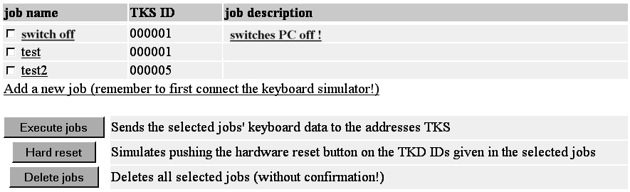

The respective job-name, the hexadecimal ID of the to be direct TKS and the description of this port are shown .
Clicking a jop-name enters job configuration. Jobs are individually selectable to get executed (execute-ports-button) or deleted (delete-ports-button) resp. in arbitrary combinations. Clicking of „Reset Checkboxes“-button cancels selection.
The “hard-reset”-button simulates pushing the hardreset button on the TKD IDs given in the selected jobs. Finally, you can add further jobs to control additional newly integrated TKS.

Having selected a job in the menu before, you now enter this job´s configuration menu. Here you can specify job-name, job-address and job-description. The keyboard-data-field is used to enter the keyboard entries to be sent. There are buttons to save changes or to save date. The next page diagrammes a screenshot of the port configuration menu.

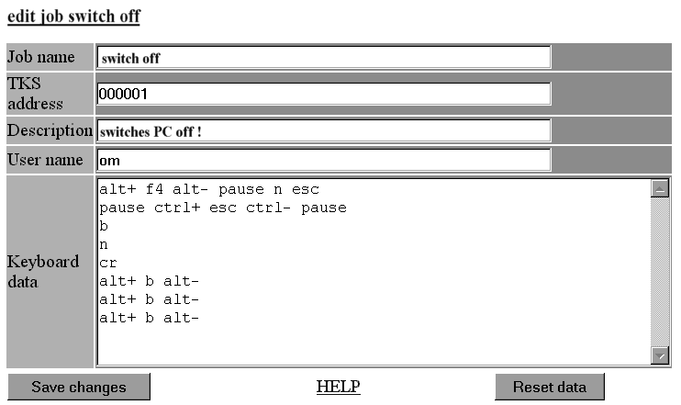

For further questions or support please visit the following URL:

www.webresetter.de

